Unit 1 Part I
Basics of Geometry

NAME: _____________________
Period: __________________
Packet Due: _____________
Quiz Date: _______________

Name: ______________________________ Date: _________________________
Unit 1: Lesson 1 & 2: Basics of Geometry
Notes
State one thing you already know about Geometry:

State one thing you want to learn about in Geometry:
 | Point | Line | Plane
Model
Words and symbols

 | Collinear | Coplanar
Define
Example

Practice: Using the diagram, answer the following questions with your trio.

- What are two other ways to name plane P?

- What are the names of three collinear points?

- State three points

- Name the point of intersection

- What are the names of four coplanar points?

- Writing: What is the difference between a line and a line segment?

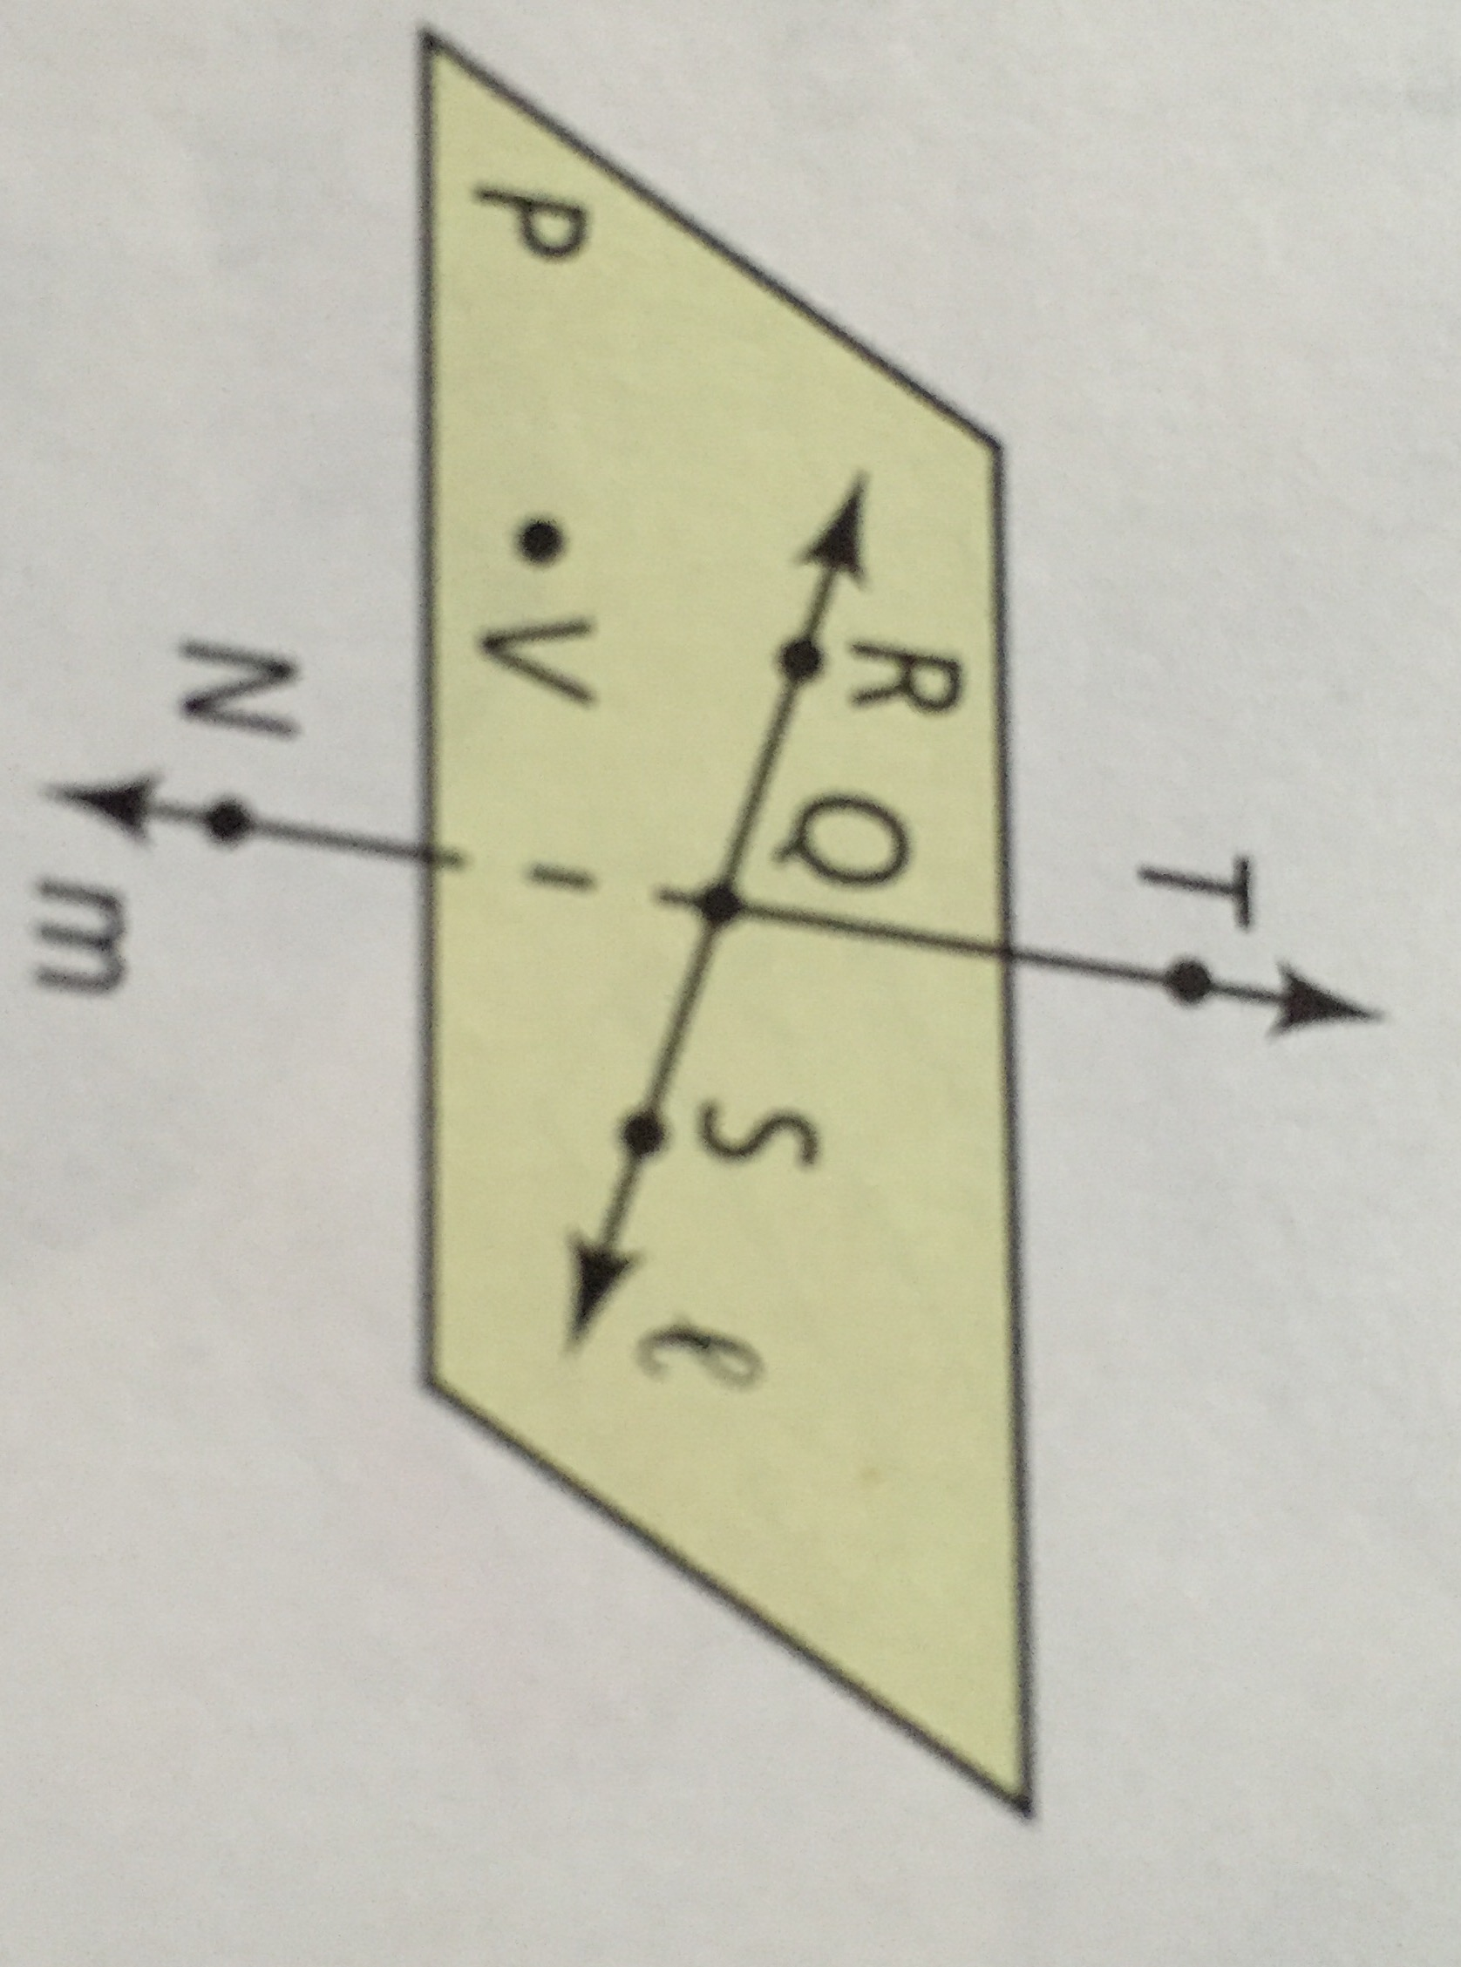

 | Segment | Ray | Opposite Ray
Model
Words and symbols

Practice:
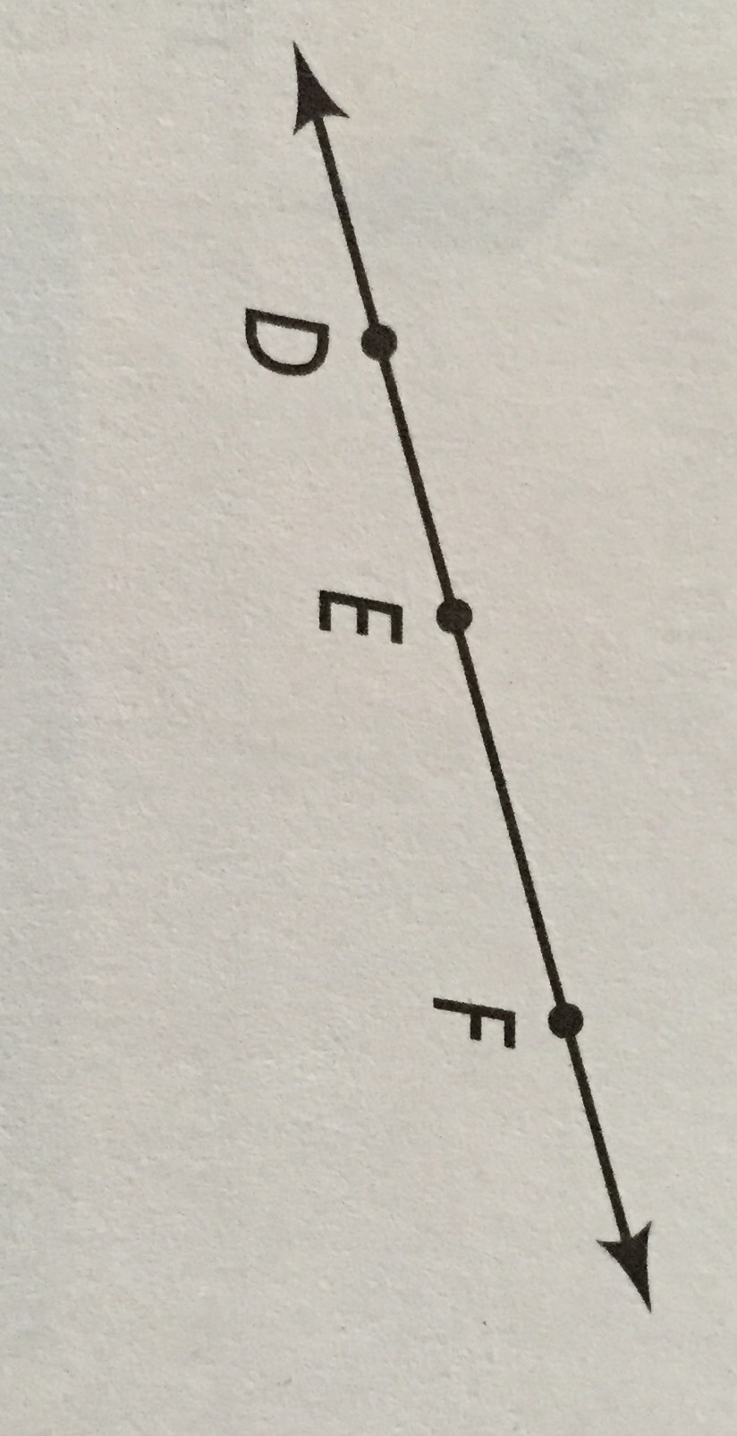
- What are the names of the segments in the figure?

- What are the names of the rays in the figure?

- Which of the rays are opposite rays?

Answer each question… | Draw a picture
What is an intersection?

Where do two lines Intersect?

Where do two planes intersect?

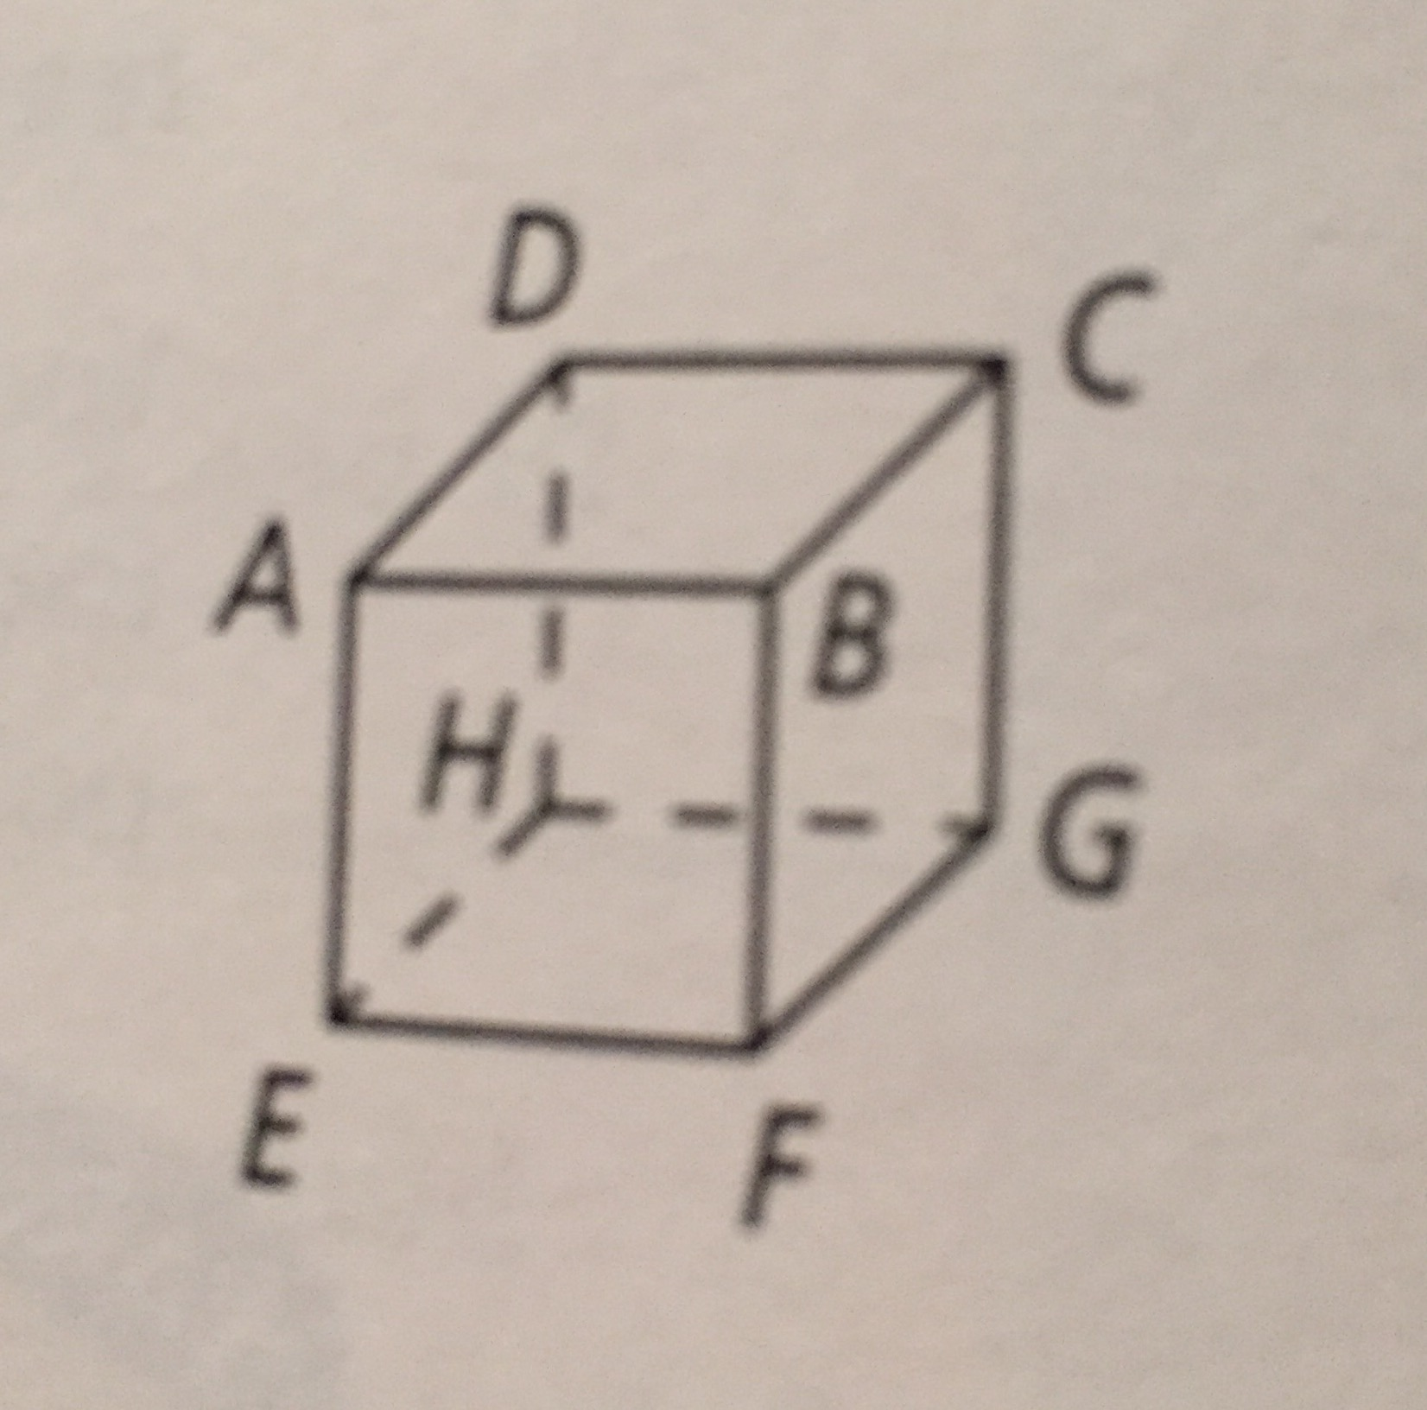
- a) Name four planes.

b) How do you know these are planes?

- What is the intersection of plane ADC and plane BFG?

- What are the names of the planes that intersect at $\overset{↔}{BF}$

Unit 1: Lesson 3: Points, lines and planes

Do Now: Why do you need to find two common points to name the intersection of two distinct planes?

___________________________________________________________________________________________________________________________.
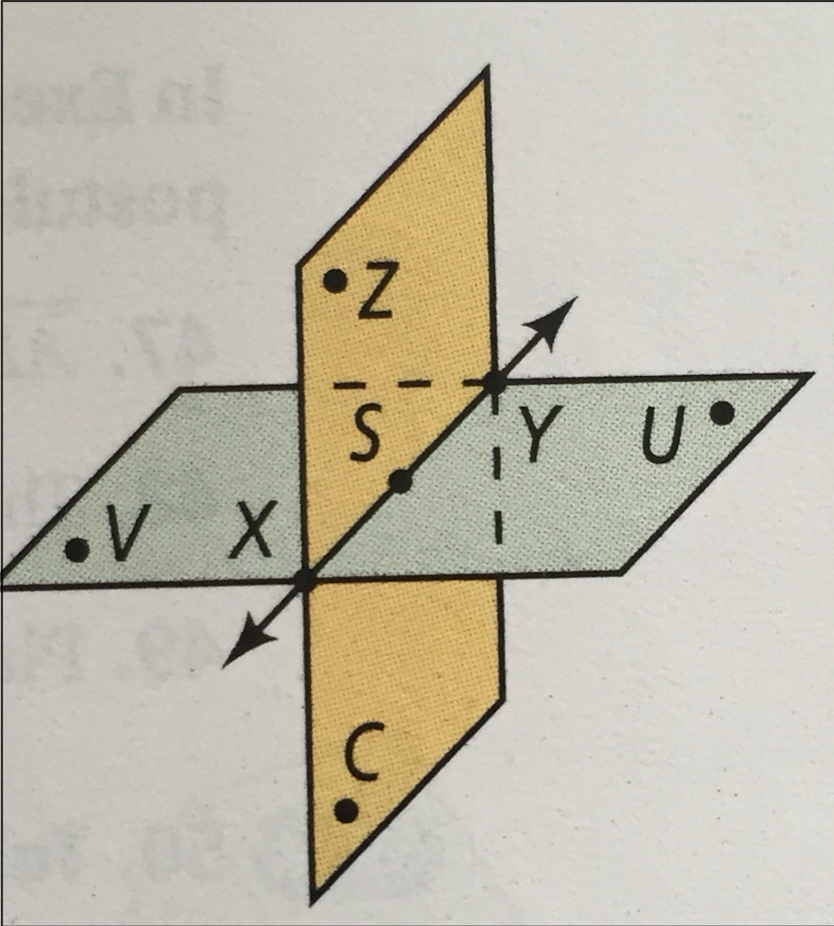
Using the diagram below write the name of…

- A plane

- The line of intersection

- Three coplanar points

What is the length of ST?
How to find distance/length on a number line?
What is the length of TU?
$\left|a-b\right|$
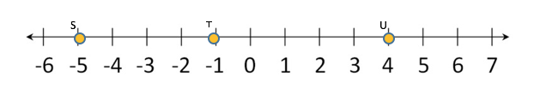

Definition: Congruent Picture: Symbol:

If point V is added to the number line above and ST $≅$ TV, what coordinate should be labeled as point V? Explain your reasoning

Define: Midpoint

Picture:

Problem 4:
B is the midpoint of AC. What are AB, BC and AC?

A B C

$$5x+1$$
$$6x-7$$

- Find the value of x. b) Find AB and BC c) Find AC

Segment Addition Postulate:

_______________________ + ______________________= _____________________

Picture

Practice Problem:
$$8x+10$$
$$3x-7$$
- If PR= 63, find the value of x. Find the measures of PQ and QR

Unit 1: lesson 3 Practice

- Solve for the missing variable

- B is the midpoint of A and C. Find the missing variable and the length of AB and AC.

- Given the figure and DG = 60 ft. x = _______ DO = ______ OG = ______
Unit 1: Lesson 4: Measuring Angles

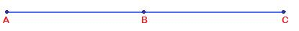
Do Now: If AC=98, what are AB and BC.
$$3x-10 2x+8$$

AB= _______________ BC= ______________
Angle
Definition: | Diagram: | Name it:

Acute Angle | Right Angle | Obtuse Angle | Straight angle

Naming Angles:
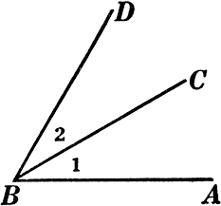
- What are two other names of ∠2?

- What are two other names for ∠CBA?

Angle Addition Postulate
If Point B is in the interior of ∠AOC, then m∠AOB + m∠BOC = m∠AOC

__________________ + __________________ = _________________

Picture Explanation:

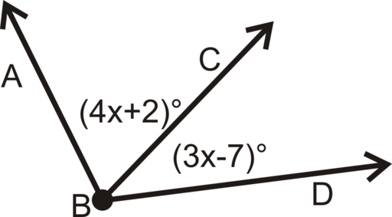
Problem 1: If m∠ABD = 35, what are m∠ABC and m∠CBD?
Step 1: Angle Addition Postulate

Step 2: Substitute

Step 3: Solve for x.

Step 4: Find the measure of each angle

For Problems 2, 3 and 4 work in your trio groups.

Problem 2: If m∠ABC = 47, what are m∠ABD and m∠DBC?
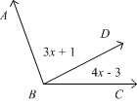

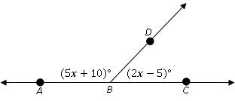
Problem 3:
∠ABC is a straight angle. What are m∠ABD and m∠DBC.

*Hint: What do we know about straight angles?

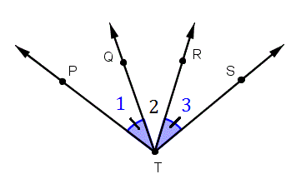
Problem 4: Solve for x
m∠PTQ = 4x-2
m∠QTR = 5x+10
m∠RTS = 2x +14

Unit 1 Lesson 5: Angle Relationships
Do Now: Create flip book

Adjacent Angles Vertical Angles Complementary Angles

Supplementary Angles Linear Pair Bisector

- Using the image below, determine if each statement is true or false. If false, change the sentence to make it true.
- <1 and <2 are supplementary

- <3 and <4 are supplementary

- <1 and <2 are complementary

- <4 and <2 are vertical

- <5 and <3 are vertical

- Name a pair of angles in the diagram below to match the description given

- supplementary to <AOD

- a pair of vertical angles

- complementary to <COD

- a linear pair

Challenge: Find the measure of <DOC

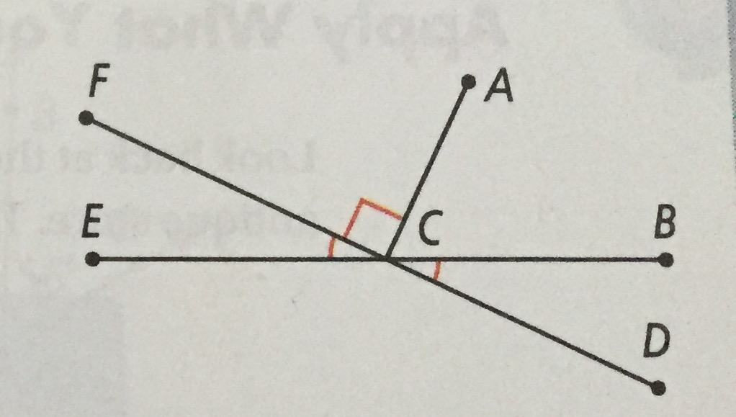
Problem 1: m∠ACB= 65
- Find m∠ACD

- Find m∠BCD

- Find m∠ECD

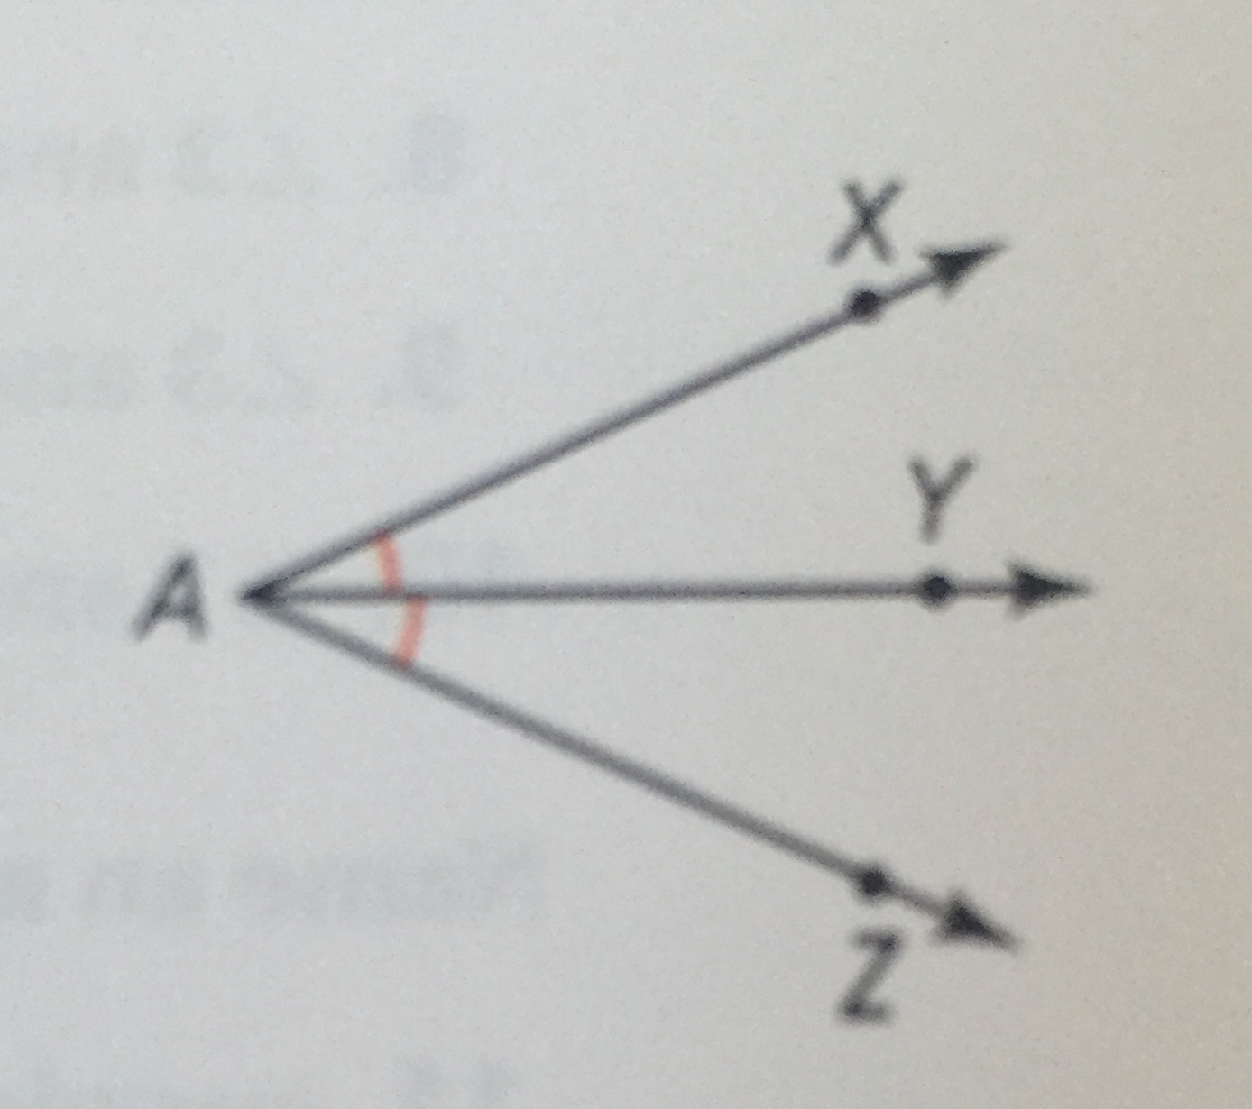
Problem 2: ∠XAY= 3X-10 AND ∠YAZ= 5X – 20

- Solve for x

- Find the measure of ∠XAY

- Find the measure of ∠YAZ

Problem 3: $\vec{AC}$ bisects $∠$DAB. If m$∠$DAC=58, what is m$∠$DAB?

Problem 4: $\vec{PB}$ bisects $∠$RPT. If m$∠$RPB= x + 2 and m$∠TPB=2x-6$. What is m$∠$RPT

Challenge: The measure of one angle is twice the measure of its supplement. Find the measure of each angle.

Draw the picture described in each statement

- Ray GI bisects ∠DGH

- $\overline{AB}$ bisects $\overline{DC}$ and intersects at E

- ∠ABC and ∠CBD are a linear pair

- $\overset{⃡}{RS}$ intersects $\overline{TV} at x$

- Plane XYZ intersects plane ABC at $\overset{⃡}{AZ}$

