Unit 1 Part II
Basics of Geometry

NAME: _____________________
Period: __________________
Packet Due: _____________
TEST Date: _______________

Unit 1 Lesson 6: Midpoint
Aim:
Do Now: Find the midpoint of AC and label it B.

C
A
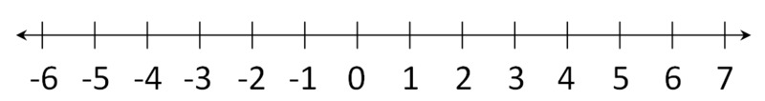

Create a formula to find the midpoint on a number line.

MIDPOINT formula
$$midpoint=\left(\frac{x_{1}+x_{2}}{2},\frac{y_{1}+y_{2}}{2}\right)$$

When two coordinate points ($x_{1},y_{1})$ and ($x_{2},y_{2})$ are given.
How does it work?
Let’s find the midpoint of $\overline{AB}$where A(-1, 3) and B(4, 6) are plotted on the coordinate plane

Step 1: Plot points and Label Points A and B (optional)

Step 2: Plug into formula and simplify in calculator

You try
- What are the coordinates of the midpoint of the line segment with endpoints (2,-5) and (8,3).

- What are the coordinates of the midpoint of a line segment with endpoints (5, 3) and (1/2, 7)

- Square LMNO is shown in the diagram below. What are the coordinates of the midpoint of diagonal $\overline{LN}$

- The center of circle Q has coordinates (3,-2). If circle Q passes through R(7,1), what is the length of its diameter?

- M is the midpoint of AB. If the coordinates of A are (-1,5) and the coordinates of M are (3,3), what are the coordinates of B?

Lesson 6: Homework
- The midpoint of AB is (-1,5) and the coordinates of point A are (-3,2). What are the coordinates of point B?

- In the diagram below, quadrilateral ABCD has vertices A(-5,1), B(6,-1), C(3,5), and D(-2,7). What are the coordinates of the midpoint of diagonal AC?

- Challenge: In the diagram below of circle C, QR is a diameter, and Q(1,8) and C(3.5,2) are points on a coordinate plane. Find and state the coordinates of point R.

Unit 1 Lesson 7: Distance
Aim:
Do Now: List all of the perfect squares and simplify each radical:

$$1^{2}= 2^{2}= 3^{2}= 4^{2}= 5^{2}= 6^{2}= 7^{2}= 8^{2}= 9^{2}= {10}^{2}=$$

$$\sqrt{32} \sqrt{54} \sqrt{44} \sqrt{8} \sqrt{75} \sqrt{80}$$

How do we find distance on the coordinate plane?
$$distance=\sqrt{{\left(x_{2}-x_{1}\right)}^{2}+{\left(y_{2}-y_{1}\right)}^{2}}$$

Steps
- Label Points $(x_{1},y_{1}) and (x_{2},y_{2})$
- Plug points into formula
- Simplify: Put in calculator or simplify the radical

When should I use the distance formula? ____________________________________________

Let’s try: Find the length of the line above.
Round to the nearest tenth Leave in simplest Radical Form

What do you notice about the two answers?

______________________________________________________________
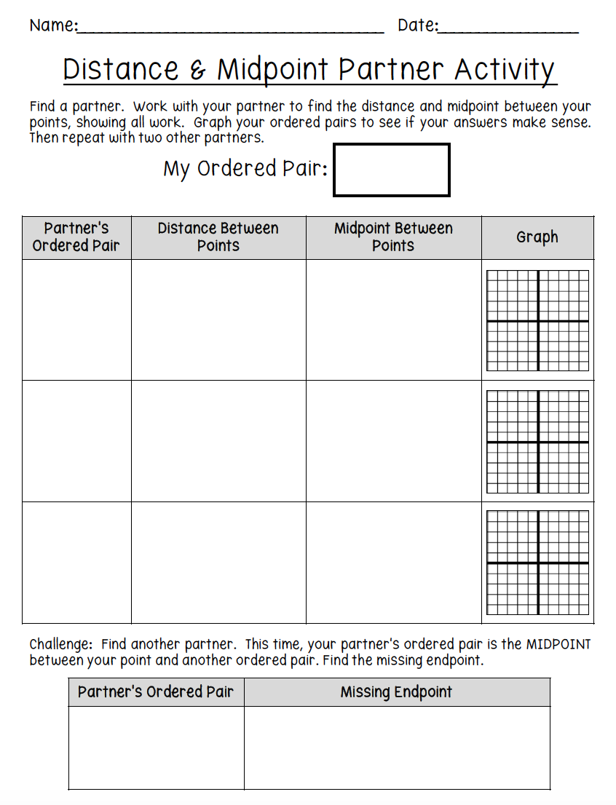
Lesson 7: Homework
- What is the length of the line segment that joins the points whose coordinates are (4,7) and (-3,5)? Round your answer to the nearest tenth.

- What is the distance from point A(4,2) and point B(10, -4) on the coordinate plane? Leave your answer in simplest radical form.

- Line segment AB has endpoint A located at the origin. Line segment AB is longest when the coordinates of B are… (SHOW ALL WORK)
- (3, 7) b) (2, -8) c) (-6, 4) d) (-5, -5)

- Jerry and Jean Jogger start at the same time from point A shown on the accompanying set of axes. Jerry travels from point A to point R to point S and then to point C. Jean jogs from point A to point C. If both joggers are going at the same speed, which jogger reaches point C first? Justify your reasoning.

- The coordinates of the endpoints of FG are (-4,3) and (2,5). Find the length of FG in simplest radical form.

Putting it All Together:
Do Now: Lesson 8

Triangle ABC has coordinates A (3, 9), B (5,1) and C (9, 5). D is the midpoint of AB and E is the midpoint of AC.

  - Graph the points A, B, and C (make sure you label them). Find the coordinates of points D and E. Show all work.

D =

E =

  - Plot points D and point E on the graph and label.

  - Find the length of BC. Show all work.

  - Find the length of DE. Show all work.

  - What is the relationship between AC and DE?

Lesson 8: Practice Area and Perimeter in the coordinate plane.
Aim:
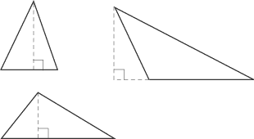
Triangle
Perimeter =
Area =

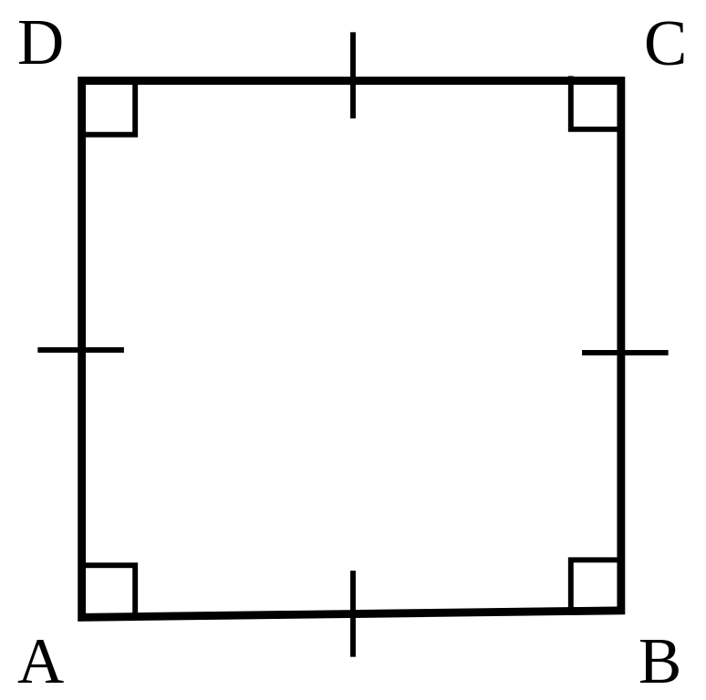
Square
Perimeter =
Area =

Rectangle
Perimeter =
Area =

Circle
Circumference =
Area =

Take out your white boards and work with your trio
_ _ _ _ _ _ _ _ _ _ _ _ _ _ _ _ _ _ _ _ _ _ _ _ _ _ _ _ _ _ _ _ _ _ _ _ _ _ _ _ _ _ _ _ _ _ _ _ _ _ _ _ _ _
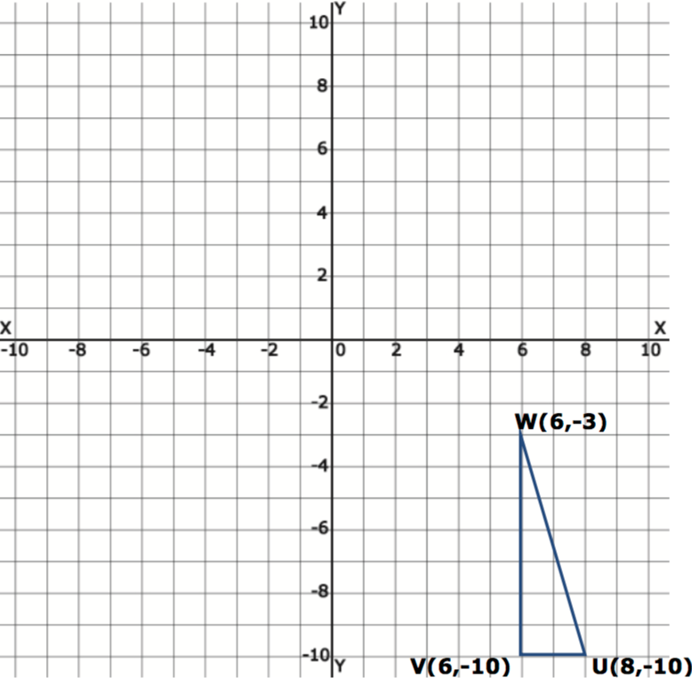
Coordinate Geometry: Area and perimeter on the coordinate Plane
Finding the Perimeter:
Step 1: Identify the coordinates of each point.

Step 2: Find the length of each side

Step 3: Plug the values into the perimeter formula $A=S_{1}+S_{2}+S_{3}$
Finding the Area:
Step 1: Identify the coordinates of each point.

Step 2: Find the base

Step 3: Find the height

Step 4: Plug the values into the area formula $A=\frac{1}{2}bh$
TRIANGLE

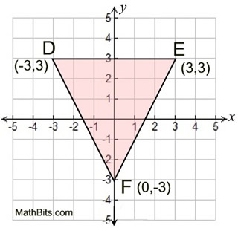
Finding the Area: Finding the Perimeter:
TRIANGLE

Finding the Area: Finding the Perimeter:
Rectangle

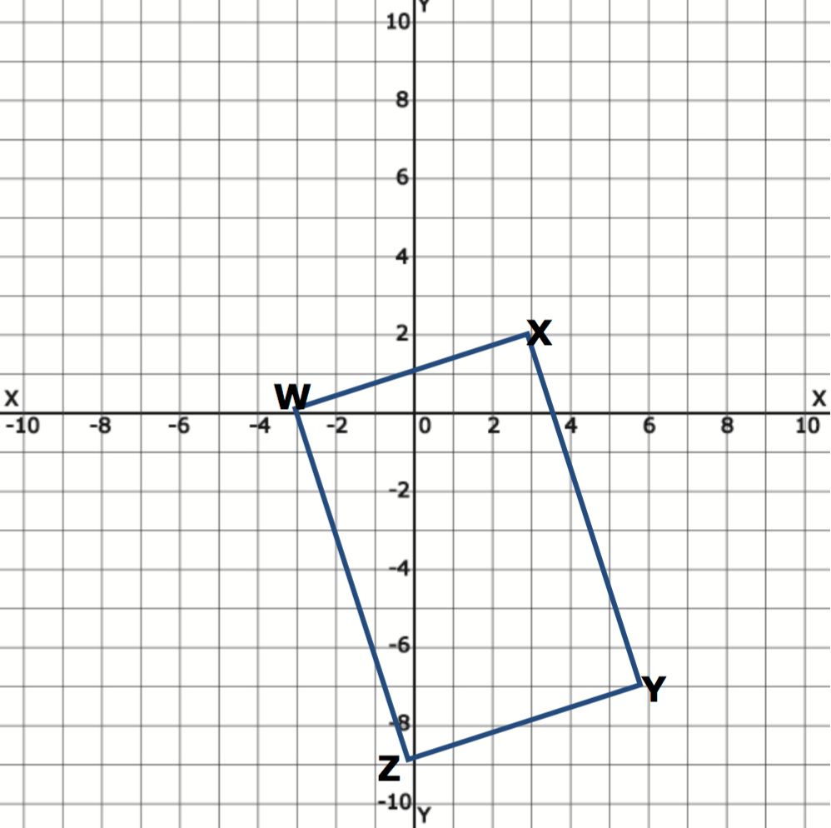

Square
Finding the Area: Finding the Perimeter:
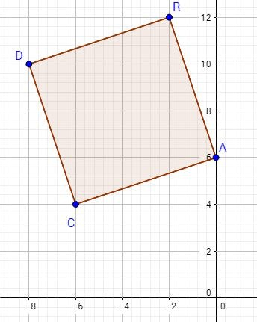

Unit 1: lesson 8: Homework
- Triangle ABC has coordinates A(-6, 2), B(-3, 6) and C(5, 0). Find the perimeter of the triangle. Leave answer in simplest radical form.

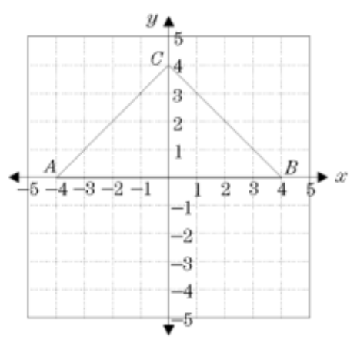
- What is the area triangle ABC?

- Find the area of square ABCD with vertices A(-1, 2), B(3, 2), C(-3, -2) and D( -1, -2).

- Square ABCD has vertices A(-2, -3), B(4, -1), C(2, 5) and D(-4, 3). What is the area of the square?

Lesson 9: Guided notes: Partitioning a line Segment
Aim:
Question: Directed line segment PT has endpoints whose coordinates are P(-2,1) and T(4,7). Determine the coordinates of point J that divides the segment in the ratio 2:1.
Brainstorm with your groups:
What is the question asking and how can I solve the problem?

Steps to solve graphically:

Or use the formula below:
$$\left(x, y\right)=(x_{1}+k\left(x_{2}-x_{1}\right),{ y}_{1}+k\left(y_{2}-y_{1}\right))$$
where k is the ratio written as numerator/(numerator + denominator)

Lesson 9: Classwork
Directions: In your group, answer your given question on a separate sheet of paper. Show all work and be prepared to share your solving strategy with the class.
HW: all questions should be completed on graph paper for HW/CW

- Group 1: What are the coordinates of the point on the directed line segment from K(-5,-4) to L(5,1) that partitions the segment into a ratio of 3 to 2?
1 (-3,-3)

- Group 2: Directed line segment PT has endpoints whose coordinates are P(-2,1) and T(4,7). Determine the coordinates of point J that divides the segment in the ratio 2 to 1.

- Group 3: Point P is on segment AB such that AP: PB is 4:5. If A has coordinates (4,2), and B has coordinates (22,2), determine and state the coordinates of P.

- Group 4: The coordinates of the endpoints of AB are A(-6,-5) and B(4,0). Point P is on AB. Determine and state the coordinates of point P, such that AP: PB is 2:3.

- Group 5: Point Q is on MN such that MQ: QN is 2:3. If M has coordinates (3,5) and N has coordinates (8,-5), the coordinates of Q are

- Group 6: Point P is on the directed line segment from point X(-6,-2) to point Y(6,7) and divides the segment in the ratio 1:5. What are the coordinates of point P ?

