Parallel Lines have so much in common, it’s a shame they will never meet.

Do Now: Draw a picture description for each of the following terms:
Parallel Lines | Coplanar lines that do not intersect  Symbol:
Parallel planes | Planes that do not intersect | 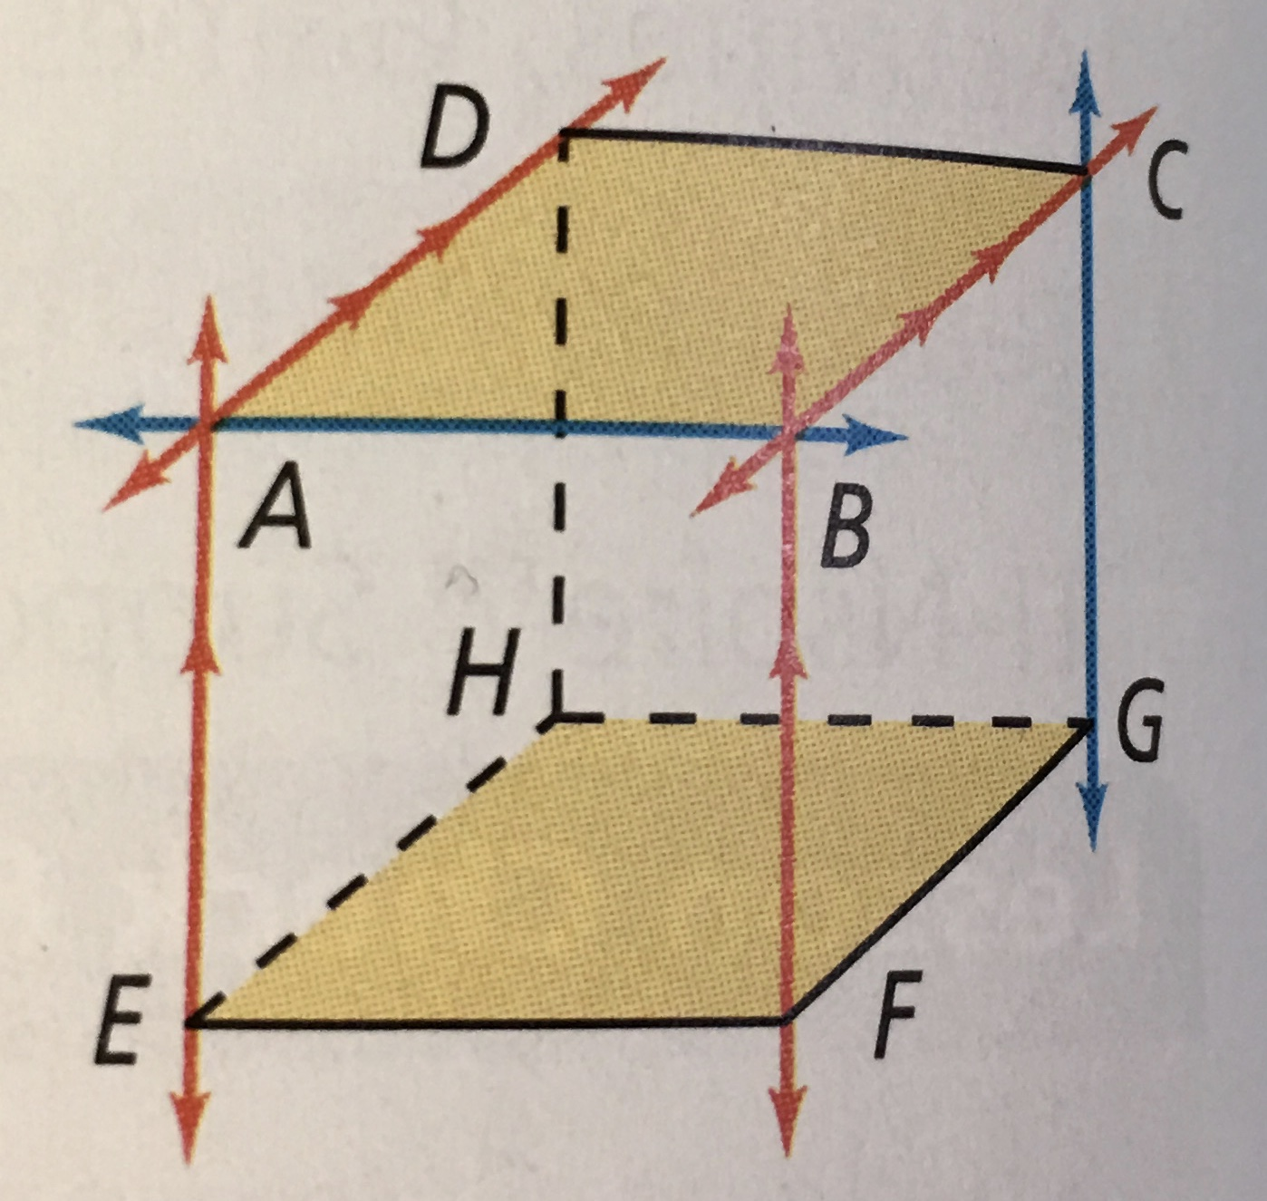
Transversal | A line that intersects two or more coplanar lines at distinct points.
Perpendicular lines | Line that’s intersect and form right angles
Two parallel Lines cut by a transversal | Two parallel lines that are both intersected by another line

Lesson 1 Practice:
Step 1: Draw a picture
Step 2: Fill in the blank
In a plane, if a line is perpendicular
to one of two parallel lines, then it is also

In a plane, if two lines are perpendicular
to the same line, then they are

Example 1: Fill in the correct symbol $∥or⊥$
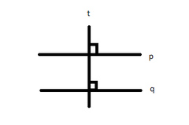
t ______ p
t ______ q

p ______ q because ________________________________

Example 2: Draw a picture and answer the following question.
Main street intersects Avenue A and Avenue B. Avenue A is parallel to Avenue B. Avenue A is also perpendicular to Main street. How are Avenue B and Main Street related?

