- Vocabulary
- Know how to name each of the vocabulary words learned this unit
- Know the images of each vocabulary word
- Know the intersections of lines and planes.
- Measuring segments
- Measuring Segments on a number line $\left|a-b\right|$
- Understand the meaning of congruent segments and the symbol for congruence
- Understand how to carry out the segment addition Postulate (Part + Part = Whole)
- Measuring Angles
- Know how to name an angle (three points with the vertex in the middle)
- Understand the differences between acute, right, obtuse and straight angle.
- Understand the meaning of congruent angles
- Know how to use and draw angle bisectors.
- Apply complementary, supplementary, linear pair and vertical angles to find the measure of angles
- Midpoint and Distance
- Know the midpoint formula and apply it to find the midpoint of a line segment on a coordinate plane and a number line
- Understand the use of the distance formula in the coordinate plane
- Area, Perimeter and Circumference
- Understand how to find the perimeter and area of shapes both on and off the coordinate plane
- Rectangle, Square, Triangle, and Circle

Regents Questions:
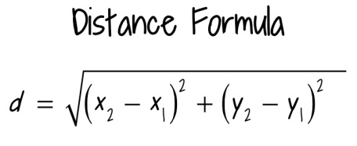
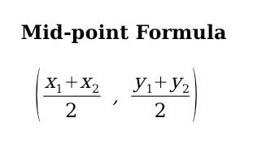

Finding area and perimeter of triangles, rectangles and squares.
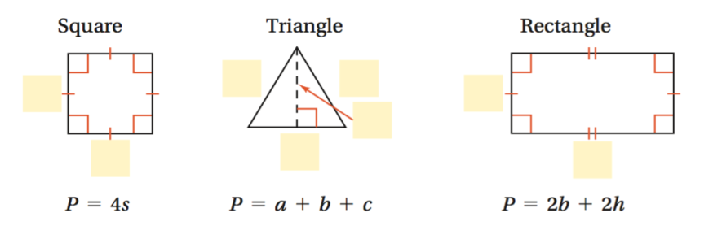

Partitioning line segments
$$\left(x, y\right)=(x_{1}+k\left(x_{2}-x_{1}\right),{ y}_{1}+k\left(y_{2}-y_{1}\right))$$
where k is the ratio written as numerator/(numerator + denominator)
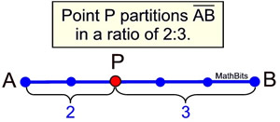

Non-Regents Review for Unit Test # 1 Geometry
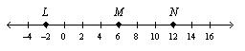

- Is point M a midpoint of LN? Explain!

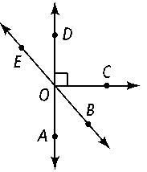
- Name an angle or angles in the diagram described by each of the following.

- complementary to ∠BOC _______________

- supplementary to ∠DOB _______________

- adjacent and supplementary to ∠AOC _______________
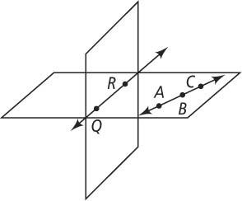

- Name the intersection of the two planes to the right.

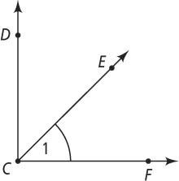
- Use the figure at the right for a – d.

- What are two other names for ∠1? ____________________
- If m∠DCF = 90, m∠DCE = 3x + 12 and m∠FCE = 4x + 1, find the value of x.

- Ray GI bisects ∠DGH so that the measure of ∠DGI is x-3 and the measure of ∠IGH is 2x – 13.
What is the value of x? **Draw a picture.

- If m$∠$1 = 3x + 40 and m$∠$2 = 5x - 20, solve for x if:
a) ∠1 and ∠ 2 are vertical angles b) ∠1 and ∠2 form a linear pair

- Using the diagram to the right, name:
2
  - one pair of vertical angles _______________________________
1
3

4
5
  - two linear pairs_____________________________

  - two pairs of adjacent angles______________________________________________

- Find the midpoint of the segment with endpoints (-4, 8) and (6, -1).

- What is the circumference and area of a circle whose center is (0, 0) and a point on the circle (2, 6).

- What is the area and perimeter of a square with vertices (0, 2), (2, 0), (0, -2) and (-2, 0)?

